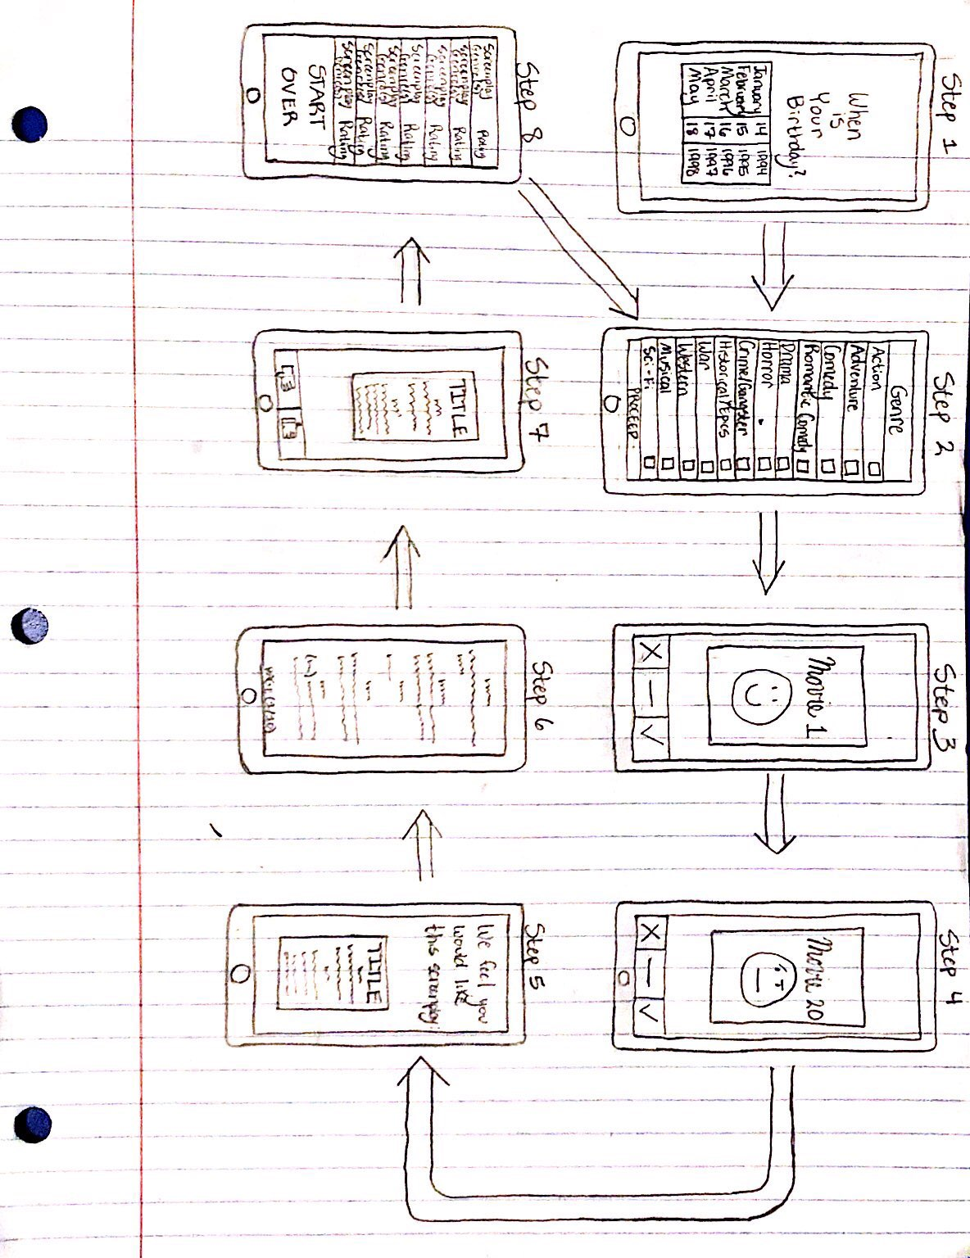

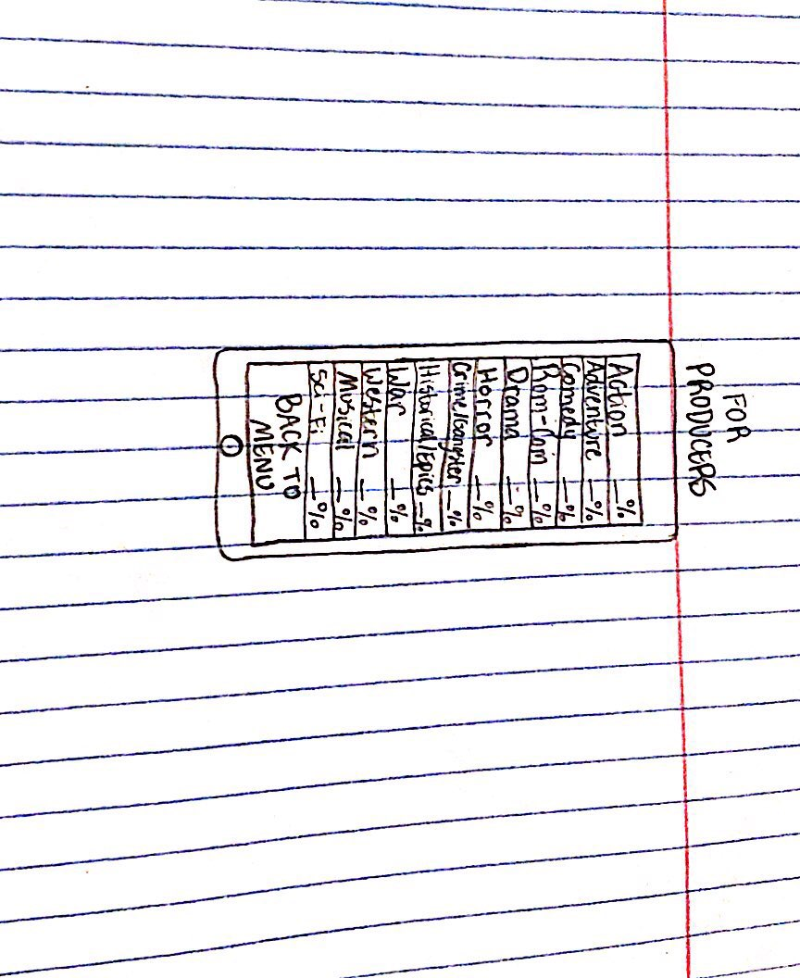

**Step 1:** Users will register their birthday. This is information that the app will take into consideration when finding relevant movies that the user will rate.

**Step 2:** Users will then check the boxes next to the genres of the movies that they enjoy watching.

**Step 3:** The app- based on the responses that the users have given in the previous two steps- will present them with movies that they will respond one of three ways to: A negative opinion (marked by a red X), a positive opinion (marked by a green checkmark), and a horizontal yellow line which will indicate that the user has not seen the movie.

**Step 4:** The user will continue rating movies until they have done this twenty times.

**Step 5:** Based on how users rated the movies they were given, the application will then present them with a new screenplay that has just been produced.

**Step 6:** The users are then allowed to read a certain number of pages from the screenplay to get a general idea of the overall product.

**Step 7:** After completing the certain amount of pages that they were given to read, the user then either gives a positive or negative opinion of the screenplay.

**Step 8:** Once the user has rated the screenplay, they are taken to a new screen where screenplays are shown along with their genre(s) and the ratings they have received so far. The user from this point can either choose to read more screenplays or start the process over, at which point they are taken back to step 2.

**For Producers:** For certain users that are interested- targeted mainly at movie producers- there is another screen that allows them to look at how certain genres of movies/screenplays have been ranking amongst the total user base, showing what percentage of votes are positive feedback. This allows producers to look at this data and pick out the next best genre of movies that they should produce and, hopefully, now perform better at the box office domestically.